CMPE 314

Fall 2018

LAB 1

Diode Characteristics and Diode-Based Circuit

Joshua Bastian

Sam Sogbola

Section

1. **Purpose**

The purpose of this lab is to study the I-V characteristics of diode. We observe the current and diode voltage under DC and AC characteristics. We observe these changes under a Zener and normal diode.

1. **Equipment**

- Oscilloscope

- DC power supply

- digital multi-meter

- function generator

- diodes

- resistors

- breadboard

1. **Procedure**
2. Construct the circuit in Figure 1 with a Zener Diode
3. Sweep the DC power supply from 0V to 5V with appropriate step(0.2V). Use a multi-meter to measure the diode voltage and current each time.
4. Reverse the polarity and sweep from 0V to 25V, Use a multi-meter to measure the diode voltage and current each time.
5. Replace the DC power supply with the signal generator and construct the circuit in Figure 2. Vary the input amplitude from 0 to 10V in steps 1V.
6. Connect the Vo and Vi and measure the waveform, Record the input and output peak-peak voltages. Should be AC coupled for the input and DC coupled for the output.
7. **Measured Data**

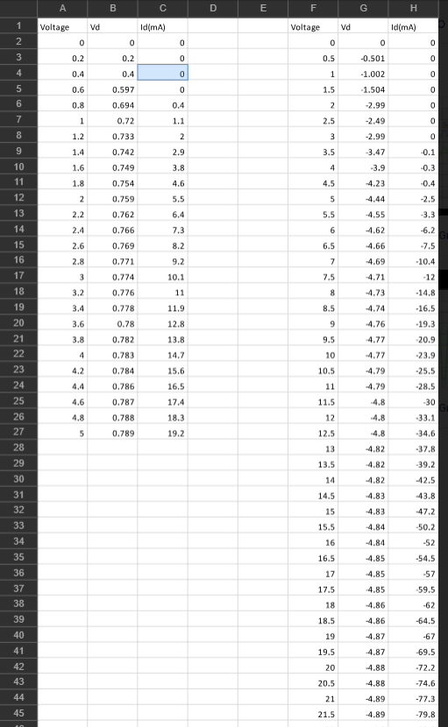

1. **Graphs**

**Input Amplitude 1V**

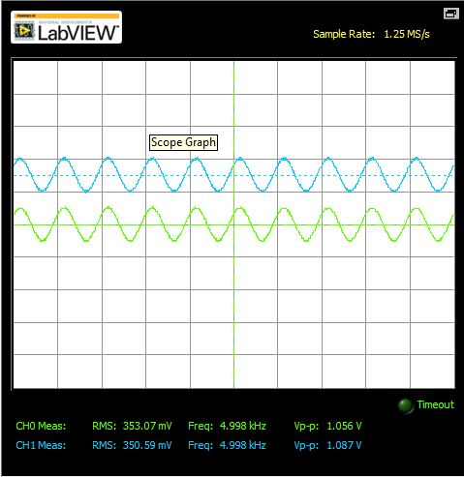

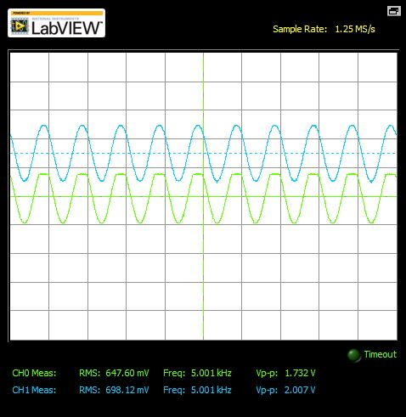Input Amplitude 2V

Input Amplitude 3V

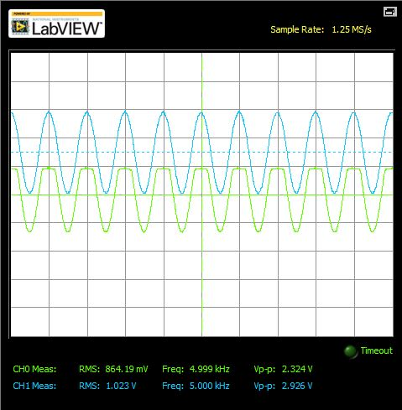

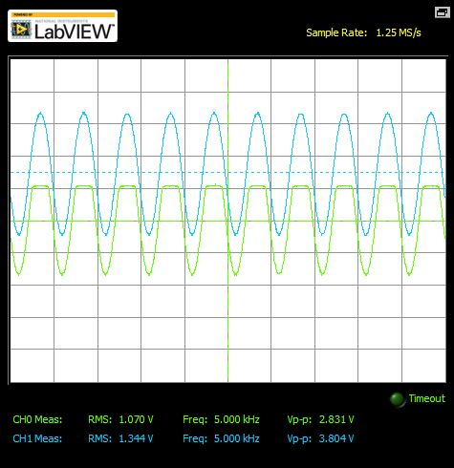Input Amplitude 4V

Input Amplitude 5V

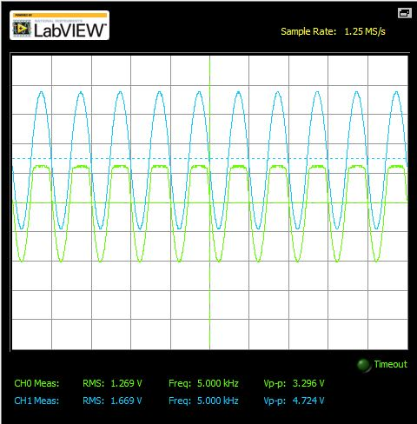

Input Amplitude 6V

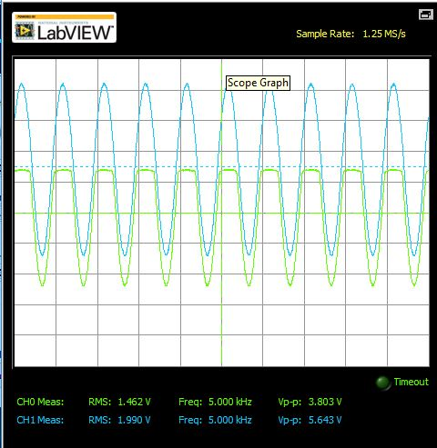

Input Amplitude 7V

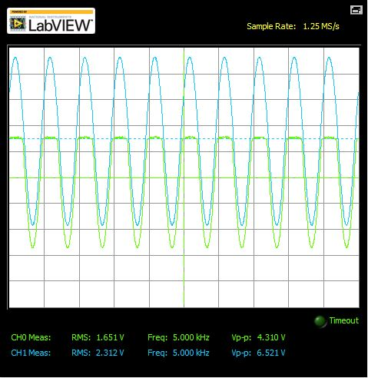

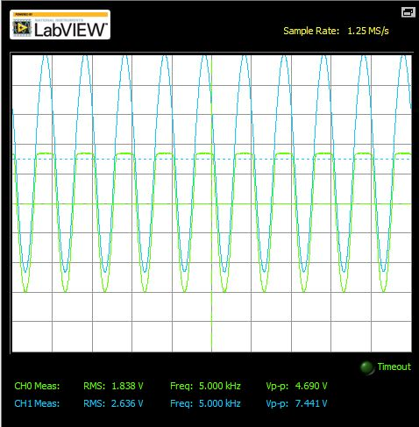Input Amplitude 8V

Input Amplitude 9V

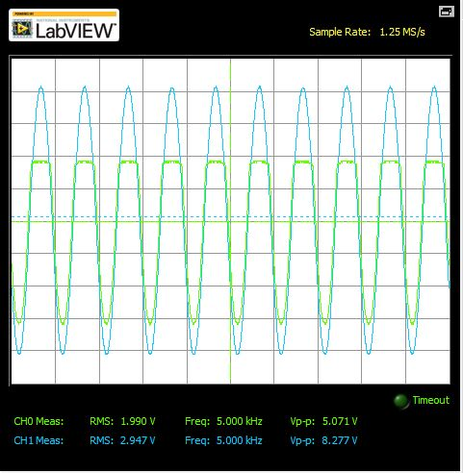

Input Amplitude 10V

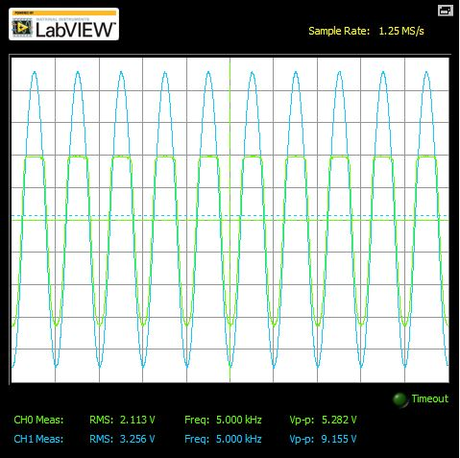

1. **Conclusion**

The first circuit was a Zener diode circuit. This circuit is implemented to be a voltage regulator. We see this characteristic in our measured data, seeding Vd didn’t vary(not significantly) even as the input voltage was varying .In analyzing the AC circuit we were able to measure the input voltage and compare it to the voltage across the Diode as the input was increasing. The input amplitude was varied from 0 to 10V in steps of 1V. We observed that because the diodes in reverse bias there’s reverse saturation current ( we can see it is minimal) because it varies with the output very minimal. This observance only lasted till 4V input, past that the Vi and Vo started to vary larger and larger. Once past a certain voltage the diode breakdown and current is allowed to move in either direction through the diode which is observed Vo being larger than Vi. We were able to observe voltage across a reverse bias diode and its breakdown once applied a break down voltage. The concept of conduction when reaching the diodes reverse breakdown voltage is what makes it used as voltage references or regulators to regulate voltage across small circuits